CIS 4911 – SENIOR PROJECT

Picture Marketing’s Social Wall

**User’s Manual**

Members: Juan Gonzalez-Llanos, Joseph Gonzalez

Mentor: Cortney Mills

09/08/2014

Instructor: Masoud Sadjadi

Web Application User Manual - Cast to Chromecast Guide

1. Chrome cast device must be connected to same network as device running Chrome browser.
2. Chrome cast extension must be installed on Chrome browser.
   1. extension link: <https://chrome.google.com/webstore/detail/google-cast/boadgeojelhgndaghljhdicfkmllpafd?hl=en>

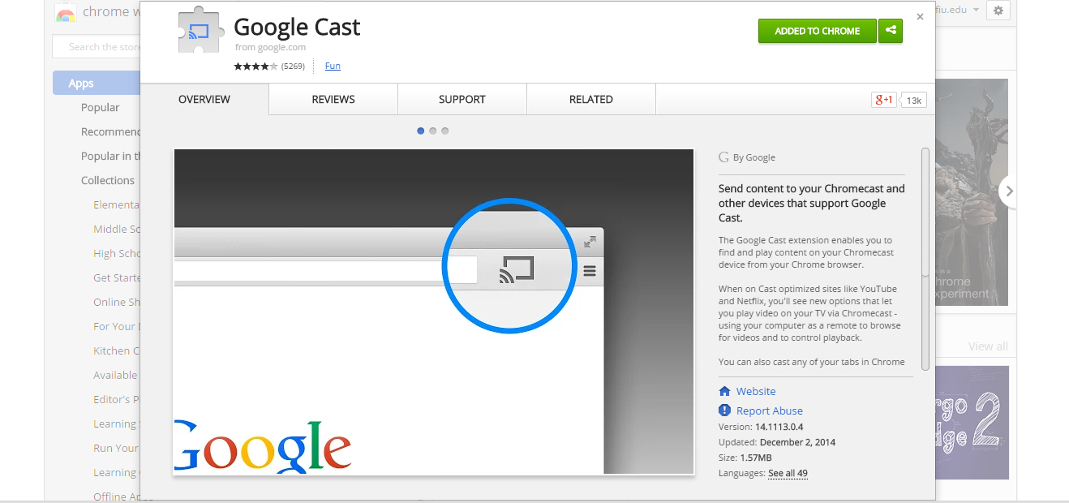

1. Users goes to web sender application <http://sw-dev.cs.fiu.edu/drive/AngularSW/app/sender/>
2. User inputs his requested settings - Clicks Cast to Chromecast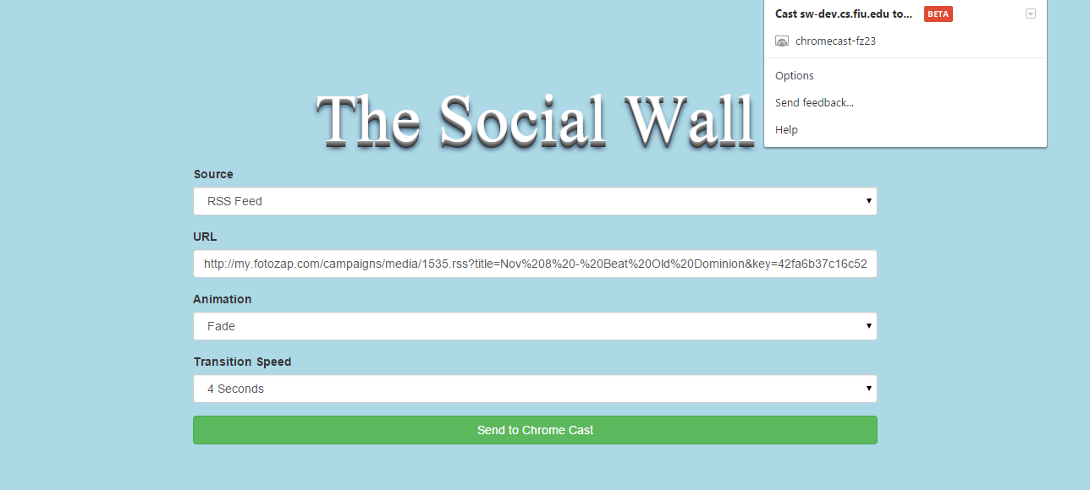
3. User selects chrome cast device on network.
4. System should begin casting onto chrome cast enabled device.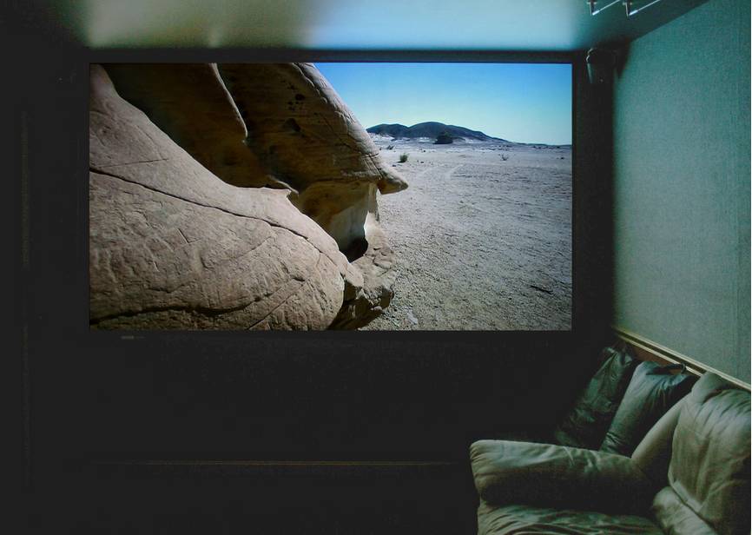

Guide to stop Slideshow

1. Go on chrome browser.
2. Click on chrome cast extension.
3. Click stop casting.
4. Application should stop execution.